
Oracy at
St Peter & St Paul CE School
Progression of skills document


How do we promote oracy at St Peter & St Paul?
- Drama opportunitites across the curriculum
- Listening and talking to storytellers, poets, authors and illustrators.
- Poetry by heart competition
- Summer and Christmas Productions
- Trips and visits to talk to people of different ages, backgrounds and cultures.
- Opportunitites for role play
- Shared reading across the school
- Opportunitites for debates and speeches
- Talk tthrough team and group tasks
- Storytelling
- Talk through play
- Forming connections with children from other settings
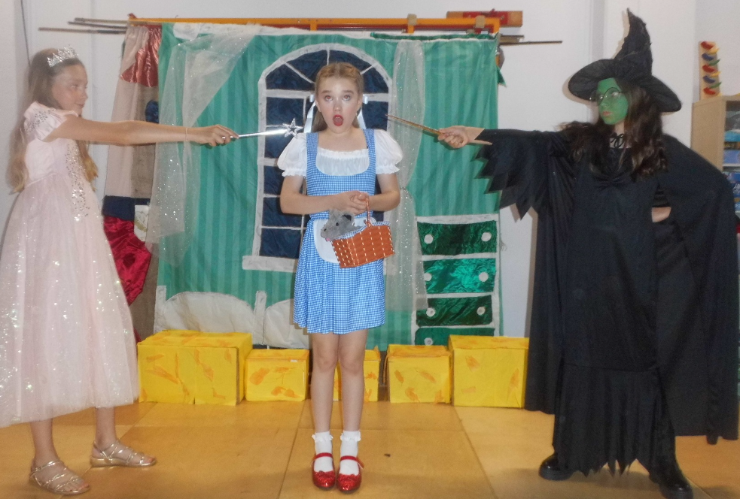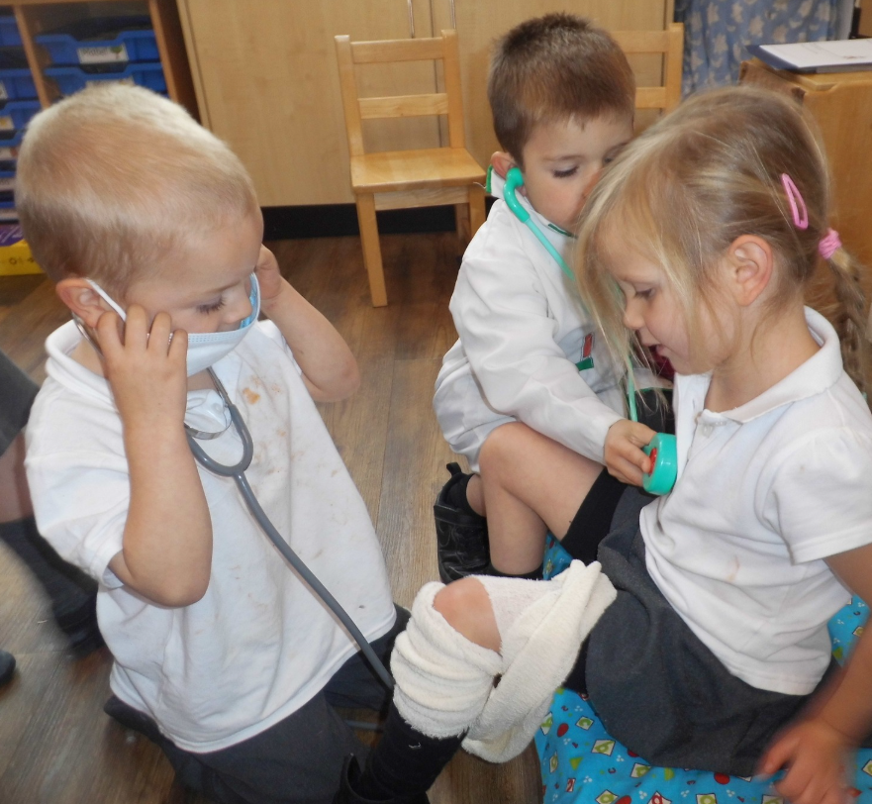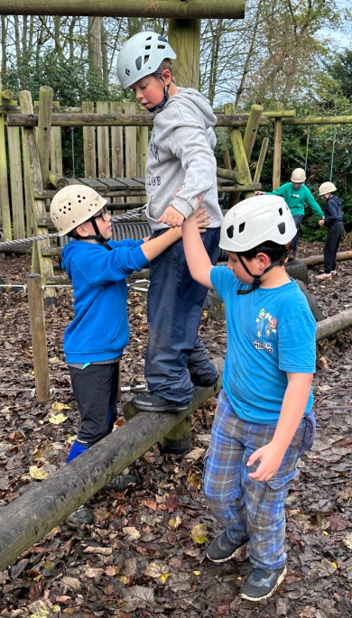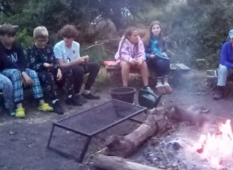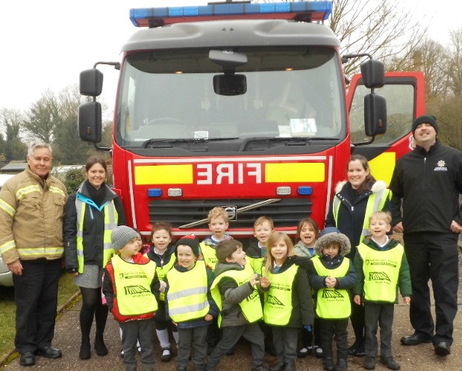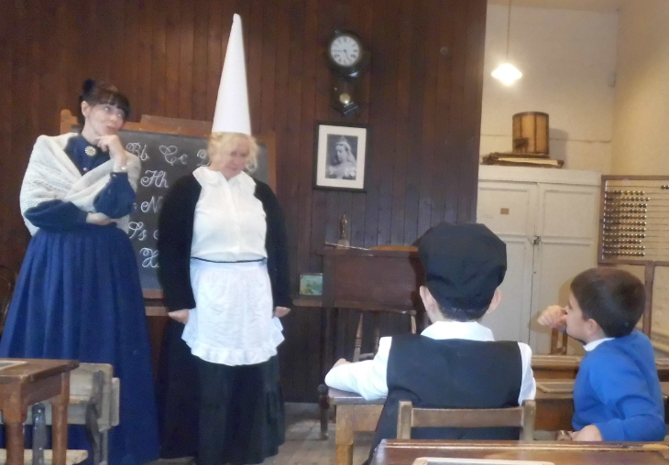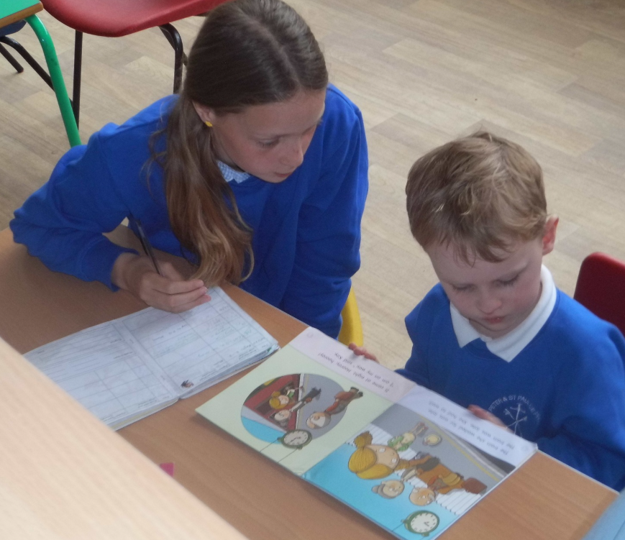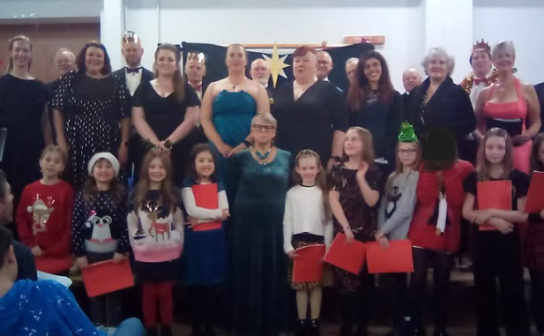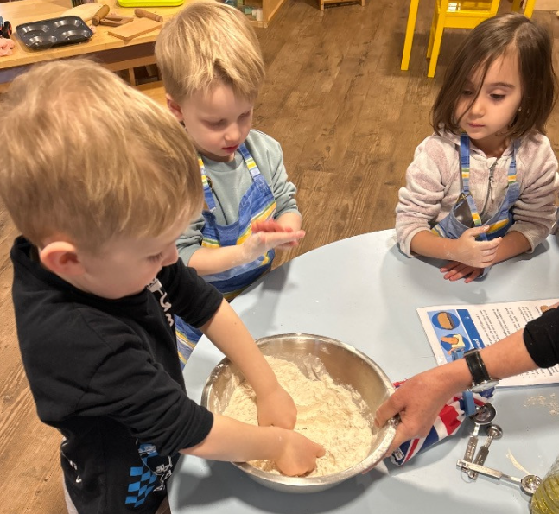

We have based our Oracy Progression Document on the Voice 21 Oracy Framework Progression Tool.

This document outlines our expectations for oracy in the classroom; it informs our curriculum planning across the school and ensures our children are developing skills as they move through the year groups. This framework outlines the physical, linguistic, cognitive and social and emotional skills that enable effective discussion, speech and communication.
Physical skills  Voice:  Pace, tone & clarity  Body language:  Gestures, postures, facial expressions & eye contact. | Linguistic skills  Vocabulary:  Appropriate & ambitious.  Language:  Register & grammar  Rhetorical techniques:  Metaphors, humour, irony & mimicry
Cognitive skills  Content:  Choice of content to convey meaning & interaction, building on the views of others.  Structure:  Structure & organisation of talk.  Clarifying & summarising:  Seeking information and clarification through questioning, summarising.  Self-regulation:  Maintaining focus on a task & time management.  Reasoning:  Giving reasons to support views, critically examining ideas & views expressed. | Social & Emotional skills  Working with others:  Guiding or managing interactions & turn taking.  Listening & responding:  Listening actively & responding appropriately.  Confidence in speaking:  Self-assurance & liveliness, flair.  Audience awareness:  Taking into account the level of understanding of the audience.

 | Physical | Linguistic | Cognitive | Social/Emotional
Reception | To use gesture to support meaning in play.  To speak audibly so you can be heard and understood. | To use talk in play to practise new vocabulary.  To join phrases with conjunctions such as “if”, “because”, “so” “but” etc. | To ask questions.  To wonder about ideas.  To use ‘because’ to develop your ideas.  To describe events that have happened to them in detail. | To listen attentively in a pair or small group.  To take turns to speak with a partner independently.
Year One | To use body language and eye contact to show listening.  To experiment with adjusting tone, volume and pace. | To use topic specific vocabulary.  To take opportunities to try new language.  To use conjunctions to organise and sequence ideas such as “firstly”, “secondly”, “finally” etc.  To use sentence stems to link others’ ideas in group discussions such as “I agree with…because…” | To consider the merits of different viewpoints.  To offer reasons for opinions.  To disagree with someone else’s opinion politely.  To explain ideas and events in chronological order. | Listen carefully to others.  To participate in group discussions independently of an adult.
Year Two | To use gesture to support the delivery of ideas.  To speak clearly and confidently in a range of contexts. | To adapt how you speak in different situations according to the audience.  To use sentence stems to signal when you are building on or challenging others’ ideas.  To use newly learnt vocabulary in an appropriate way. | To ask questions to find out more about a subject.  To build on others’ ideas in discussions.  To make connections between what has been said and your own and others’ experiences. | To encourage everyone to contribute.  To develop an awareness of audience, such as what might interest a certain group  Deliver short, pre-prepared material confidently.
Year Three | To consider position and posture when addressing an audience.  To experiment with adjusting tone, volume and pace for different audiences. | To begin to use specialist vocabulary.  To be able to use specialist language to describe your own and others’ talk.  To begin to make precise language choices. | To offer opinions that aren’t your own.  To reflect on discussions and identify how to improve.  To be able to summarise a discussion.  To reach a shared agreement in discussions. | Listen attentively, questioning and responding to others.  To adapt the content of your speech for a specific audience.  To speak with confidence in front of an audience.
Year Four | To consider movement when addressing an audience.  To consider how tone, volume and pace influence meaning. | To carefully consider the words and phrasing you use to express your ideas.  To use specialist vocabulary when discussing a known topic. | To be able to give supporting evidence and justify what views.  To ask probing questions.  To reflect on your own oracy skills and identify areas of strength and areas to improve. | To use more natural and subtle prompts for turn taking.  To develop an awareness of audience.  To consider the impact of your words on others when giving feedback.
Year Five | For body language to become increasingly natural.  To project your voice to a large audience. | To use an increasingly sophisticated range of sentence stems with accuracy.  To select specific vocabulary appropriate to the topic. | To be able to draw upon knowledge of the world to support your own point of view and explore different perspectives.  To identify when a discussion is going off topic and to be able to bring it back on track. | To listen actively for extended periods of time.  To speak with flair and passion.
Year  Six | To have a stage presence.  To adjust tone, volume and pace for a given purpose and audience. | To vary sentence structures and length for effect when speaking.  To be comfortable using idiom and expressions.  To use sophisticated vocabulary appropriate to the context and purpose of talk. | To construct a detailed argument or complex narrative.  To assess different viewpoints and present counter-arguments.  To spontaneously respond to increasingly complex questions, using evidence to justify your views when appropriate.  To acknowledge and explain changes of position. | To use humour effectively.  To be able to read a room or a group and take action accordingly.  To develop an awareness of group dynamics and invite those who haven’t spoken to contribute.

Shows & Performances  Each year, all children in our school perform on stage in our Christmas and Summer Show. | Competitions  We host a variety of competitions throughout the year.
In the classroom | Trips & enrichment opportunities

Children at Occold Primary School have a wide variety of opportunities



