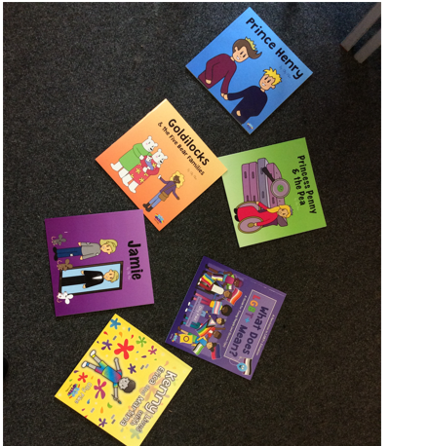
A set of Free Inclusive Books from LGBT+ author Olly Pike

