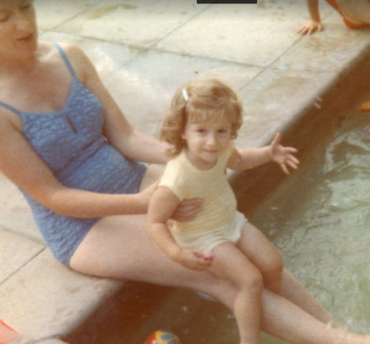
My favourite book when I was a child was Little Women by Louisa M. Alcott. My mum used to read it to me and my sister at bedtimes. I loved listening to my mum read me stories, even when I got a bit older. This book is about four sisters – The March sisters – Meg, Jo, Beth and Amy and it represents their journeys from childhood to womanhood. Their mother (who they all call Marmee) is also a main character as their father is miles from home, away with the army, in The American Civil War.
My Favourite Book as a Child – Mrs Jarvis
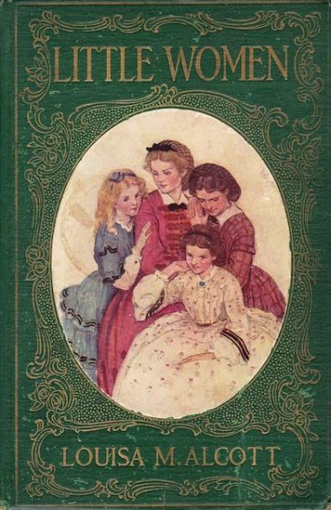
One of my favourite parts is when the family face their first Christmas without their father and Marmee persuades them to give their Christmas breakfast away to an impoverished family. The girls and their mother venture off into town with their baskets laden with food to feed the hungry children. When they return home, they discover that their wealthy, elderly neighbour, who has seen their act of kindness, sends them over a decadent, surprise dinner to make up for their lost breakfast. The two families become acquainted following these acts of kindness.
I loved the book as a child as it portrayed each of the sisters differently: Beth is timid, too timid for school and is content to stay at home and help with housework; Amy is still at school and is an artist and longs for elegance and high-society; Meg is beautiful and traditional, but she is also vain and Jo is a tomboy and hot-headed. The neighbour boy Laurie becomes close friends with the sisters, particularly tomboyish Jo. You cannot help but have a favourite sister– Jo was mine.
My sister and I spent many hours listening to our own mum read this timeless classic to us that was first published in 1868. It has now been made into a film and I actually sit and watch it with my own three daughters every Christmas. We all laugh and cry as it is a beautifully moving story about young women making their way in the world and something I feel blessed to have had read to me as a child by my own mum.

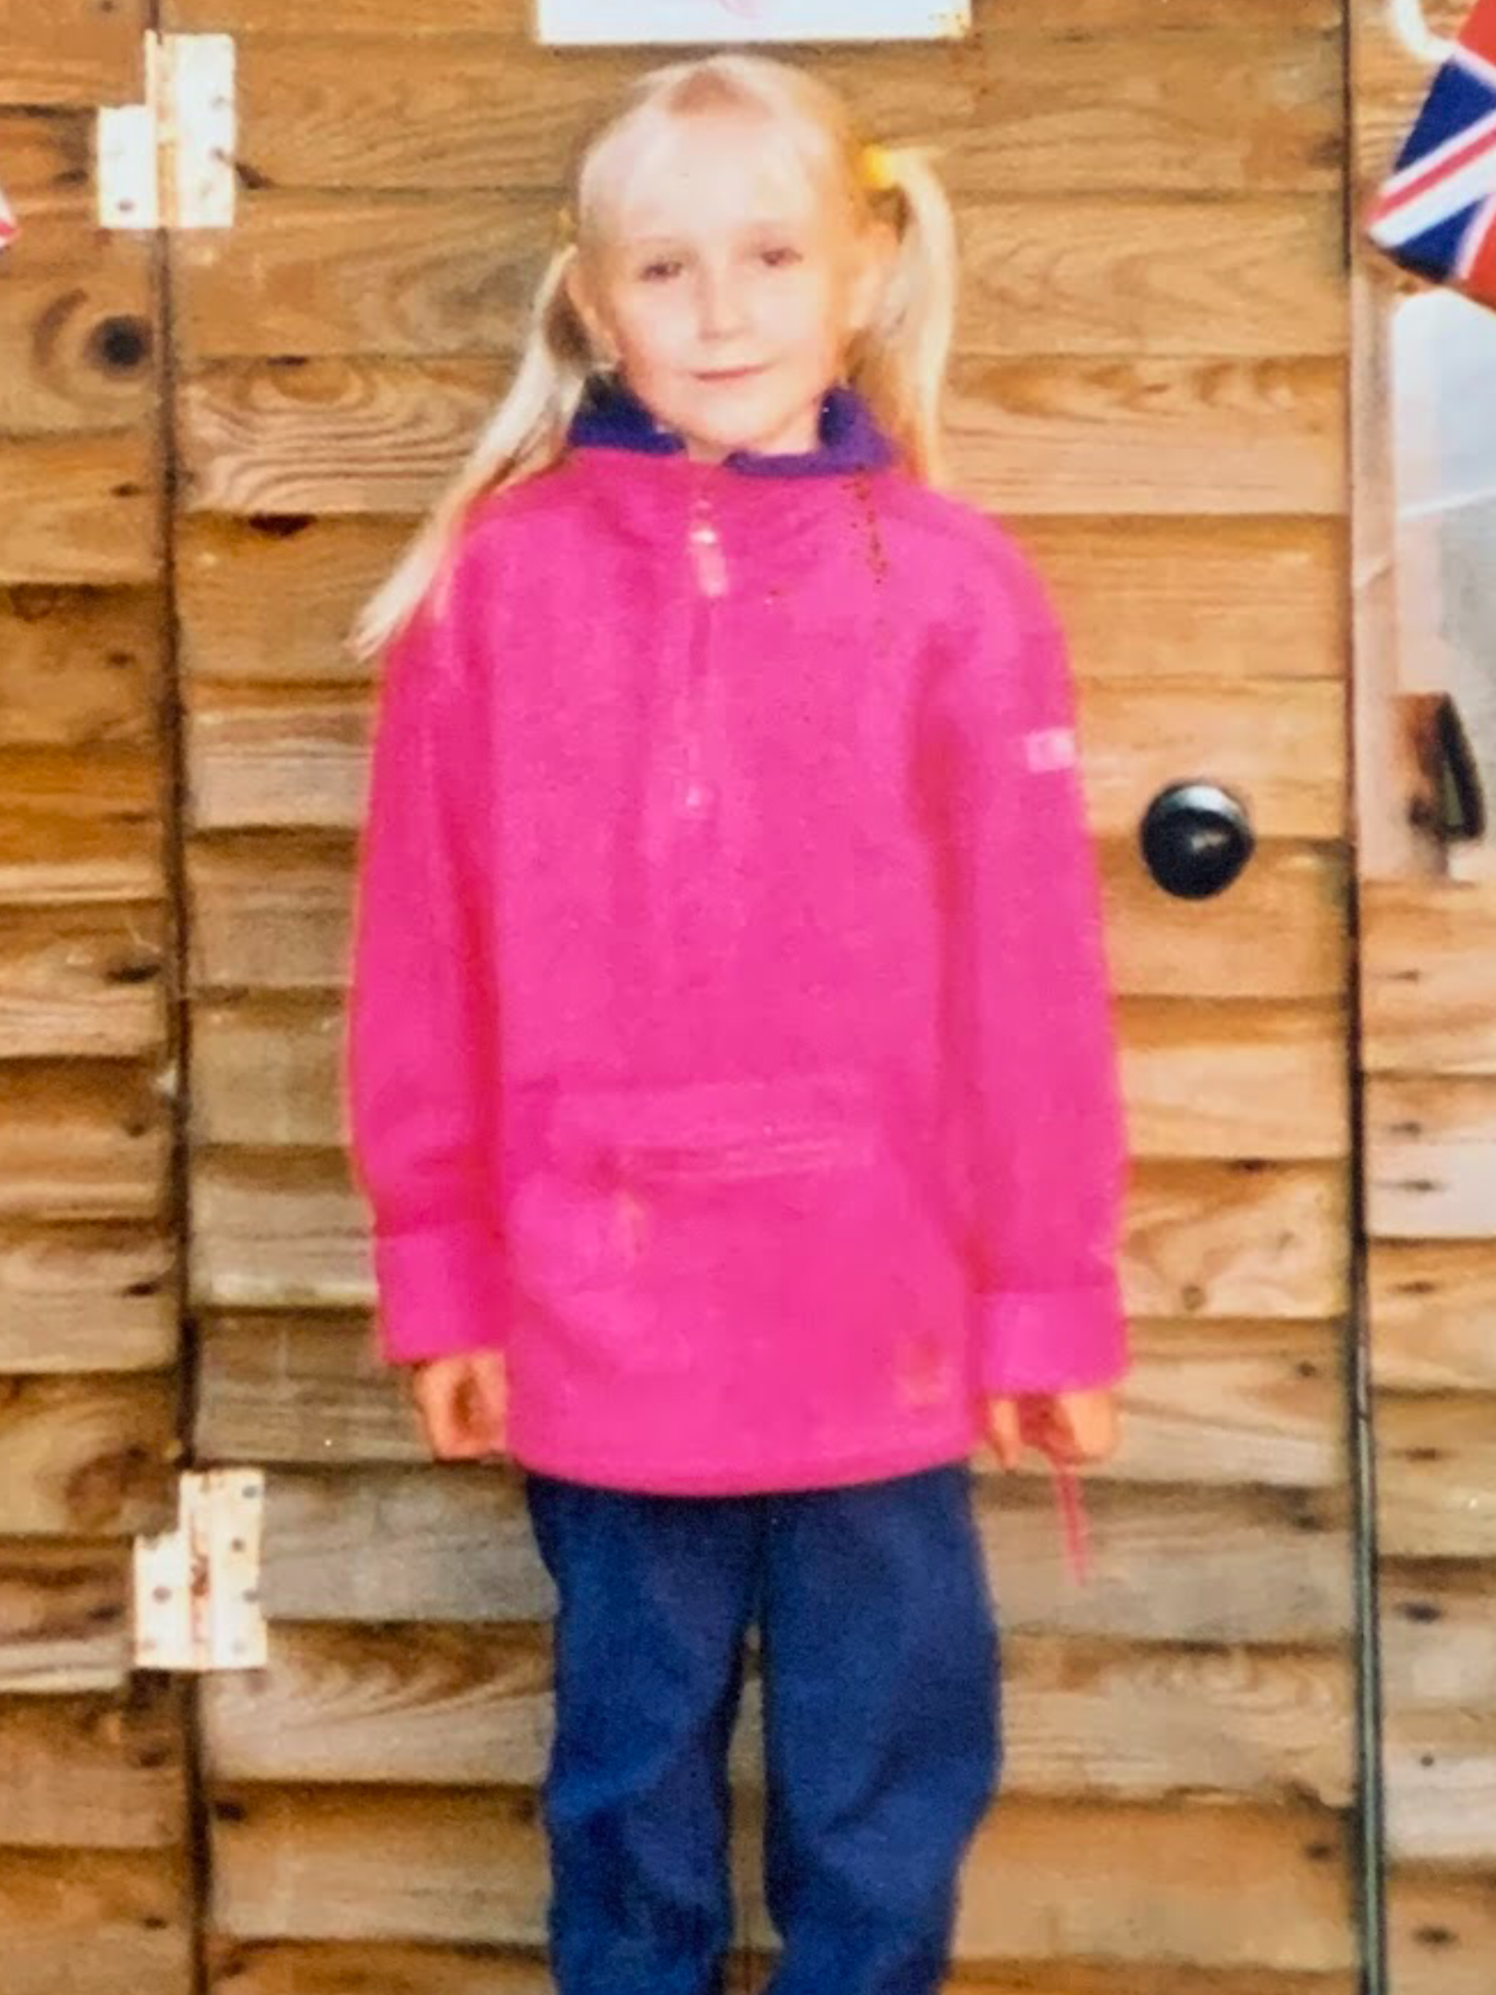
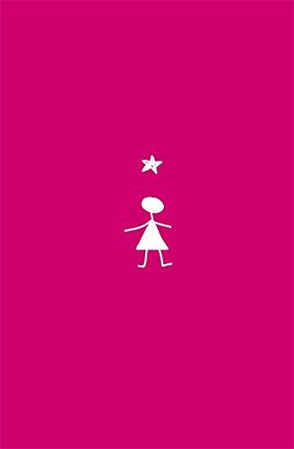
Miss Brown’s Favourite Childhood Book

My favourite book as a child was ‘Stargirl’ by Jerry Spinelli. I have vivid memories of reading and rereading this book over and over again when I was staying at my dad’s house. I think I lost count of how many times I read it!

I remember being initially interested in this book because there are no words on the front cover - no title or author name. Because this was unusual, it made me interested in what it could be about. I must have been around nine years old at the time (which is how old I am in the photo!).

The story is about a girl who doesn’t fit in at school, and about how she tries to change to get the other children to like her. I thought that she was such a unique character and that she should not have to conform to be the same as everyone else.

I still have my original copy of Stargirl on my bookshelves today. They adapted the book into a Disney+ film in 2020, which I plan to watch as it would make me feel very nostalgic!

